User Verification Test (UVT)
(To be completed after live implementation.)

UVT Date | 2/5/2022
Department
Client / Country | All
Tested By | Stephen Yao Agbeli
What was tested | All resolved fields made mandatory.  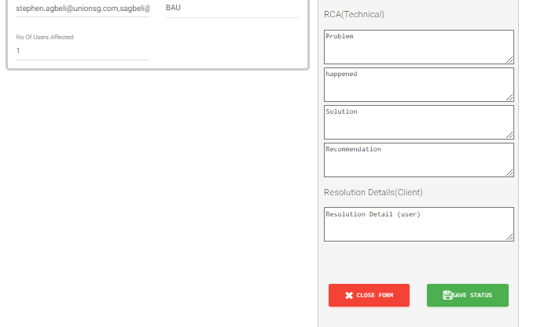
Outcome of Testing | Successful | ✔ | NON-SUCCESS | ◻
Time(Duration) | 10mins
Contact Phone No. | 0208226541
Comments ( If Any) | (Explain reason(s) for Non Success)

UVT Signed off By | Name | Designation | Signature | Date
UVT Signed off By | Stephen Yao Agbeli | RM |  | 2/5/2022

